EXPERIMENT 16 : EYE DIAGRAM ANALYSIS OF OPTICAL COMMUNICATION LINK USING OPTISYSTEM

OBJECTIVES :
- Design and establish an optical fiber communication link using OptiSystem software.
- Calculate and evaluate the Bit Error Rate (BER) for different optical source power levels.
- Analyze how variation in optical source power affects BER and overall link performance.

SOFTWARE USED : OPTISYSTEM SOFTWARE

CIRCUIT DIAGRAM:
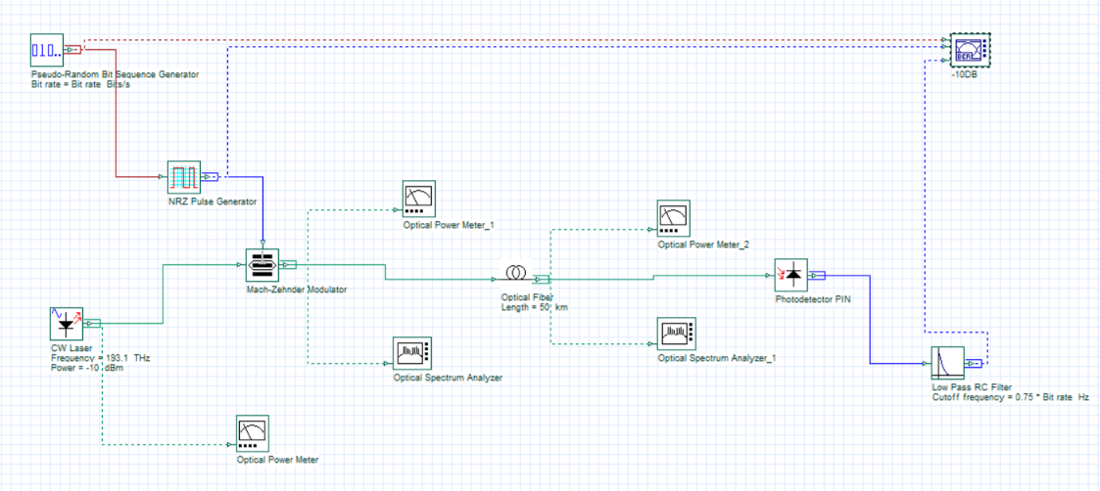
OUTPUTS:
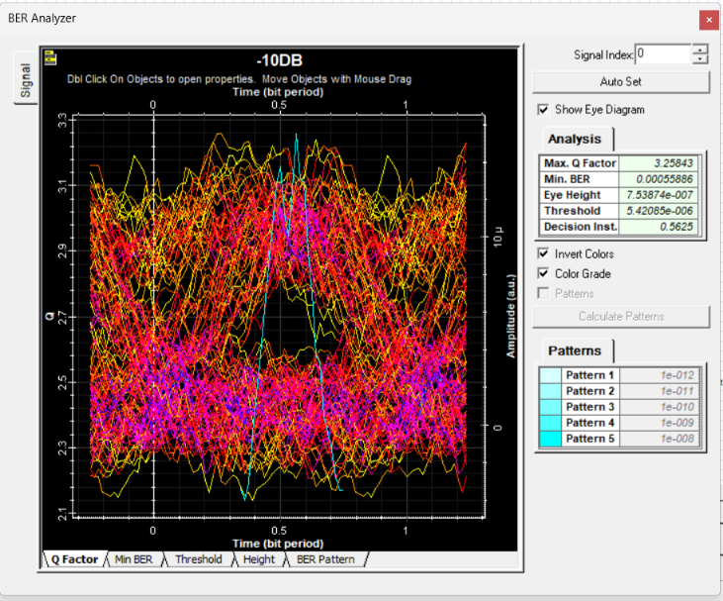 | 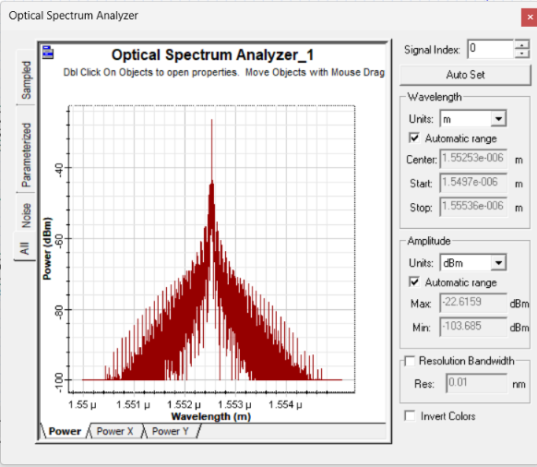
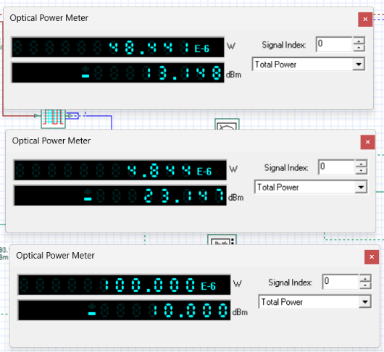
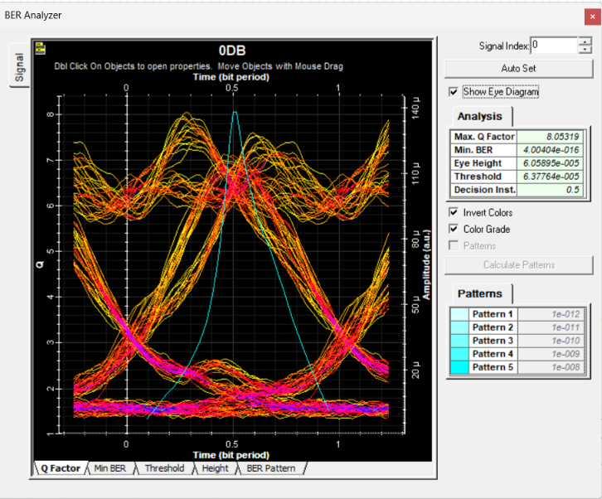 | 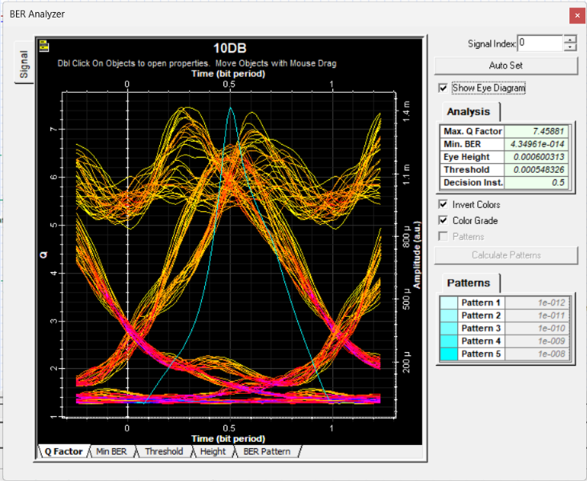

REFLECTION:
I learned to design and simulate an optical fiber communication link using optisystem and analyze eye diagrams, BER and Q-factor at different laser power levels.
I understood how optical source power affects signal quality and reliability, identifying 0 dBm as the best-performing power level based on the measured BER and Q-factor.

RUBRICS:
Objective | Assessment Criterion | Excellent – 4 | Good – 3 | Satisfactory – 2 | Needs Improvement – 1 | Weighta ge
System  Design &  Link Setup | Correct selection and connection of  OptiSystem components for the optical fiber link  (PRBS Generator,  NRZ Pulse Generator,  CW Laser, MachZehnder Modulator,  50 km Optical Fiber, PIN Photodetector,  Low Pass RC Filter, BER Analyzer). | All transmitter, modulator, fiber, receiver, and  analyzer components  are correctly selected, connected in  sequence, and  configured without errors. | All  components are present  with minor  connection or layout errors,  but the link remains functional. | Component selection is partially  complete;  minor  connection or configuration  errors impede signal flow. | Incorrect component selection or  improper setup leading to complete  simulation failure. | 20%
Parameter  Configuratio n &  Execution | Accurate setup of input parameters: CW  Laser frequency (193.1  THz), optical fiber length (50 km), and  laser power levels (-10 dBm, 0 dBm, 10 dBm). | All input parameters  and power-level test cases are accurately  set and simulated. | Test case parameters are mostly  accurate with minor setting discrepancies. | Basic parameters are  configured, but one or more  power levels are missing. | Incorrect parameter  settings or failure to run the  required power cases. | 20%
Measuremen t & BER  Observation | Accurate extraction and recording of Max.  Q-Factor, Min. BER,  Eye Height,  Threshold, and  Decision Limit from the BER Analyzer for each laser power. | Precise data  extraction for all  power levels, neatly  tabulated, with clear eye diagrams and  BER plots captured. | Data is collected with minor  omissions in  Q-factor, BER, or eye parameters. | collection with Partial data incomplete tables or  missing eye diagrams. | Inaccurate, incomplete, or  missing data and measurements. | 20%
BER & Power  Level  Analysis | Detailed evaluation of the effect of optical  source power on BER,  Q-factor, and eye opening, including receiver sensitivity and power margin. | Comprehensive  analysis correctly  relating laser power to received signal  strength, Q-factor,  BER improvement, and saturation or nonlinear effects. | Clear analysis identifying  basic trends  in Q-factor and BER  versus laser power. | Basic attempt at result analysis without  explaining physical  mechanisms such as  insufficient  received power or nonlinearity. | Erroneous or missing analysis of simulation  results and eye diagrams. | 20%
Report & Conclusion | Identification of the optimum optical  source power for reliable  communication,  comparison of low,  moderate, and high power cases, and structural clarity. | Report features clear eye diagrams,  complete output  tables, and insightful conclusions  identifying the optimum laser power. | Satisfactory report with  relevant eye  diagrams and sound  concluding summary. | Incomplete report with diagrams, missing  tables, or weak conclusions. | Disorganized or incomplete  report lacking required  diagrams and valid  conclusions. | 20%

CONCLUSION:
The study shows how optical source power affects BER and signal quality in an optical communication system. Performance depends on the transmitted power level:
    - Low Power: results in higher BER due to insufficient received signal strength.
    - Moderate Power: gives lower BER and better signal quality.
    - High Power: improves signal strength but may introduce nonlinear effects.
These results help in selecting the optimum optical source power for reliable and efficient optical communication

